
Green Society Public School
Ratnanagar-7, Sauraha, Chitwan
Date/  Class | 4 | 5 | 6 | 7 | 8 | 9 | 10
2081-02-25 | सामाजिक+  Eng-II | नेपाली+  Eng + Eng II | Eng + सामाजिक+  HRHG | सामाजिक +  Eng | Science +  Opt + HRHG | नेपाली+  Eng | English + Nepali
2081-02-27 | Eng + Maths+  Comp | Maths + Comp | Maths +  Eng II | Science + Eng II | Maths +  HPCA | Comp + Science | Science + सामाजिक
2081-02-28 | Science  +  HRHG | सामाजिक+  HRHG | नेपाली + HPE | HPCA +  Nepali + Comp | नेपाली+  English | Maths +  सामाजिक | Comp + Maths
2081-02-29 | नेपाली+HPE | Science + HPE | Science + Comp | HRHG + Maths | सामाजिक + Comp | Env. Sci + O.Maths | O. Maths  + Eco
Routine of First Achievement Test 2081
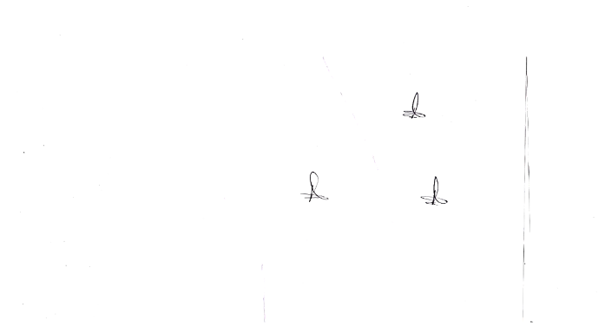
Principal

Green Society Public School
Ratnanagar-7, Sauraha, Chitwan
Date/  Class | 4 | 5 | 6 | 7 | 8 | 9 | 10
2081-02-25 | सामाजिक+  Eng-II | नेपाली+  Eng + Eng II | Eng + सामाजिक+  HRHG | सामाजिक +  Eng | Science +  Opt + HRHG | नेपाली+  Eng | English + Nepali
2081-02-27 | Eng + Maths+  Comp | Maths + Comp | Maths +  Eng II | Science + Eng II | Maths +  HPCA | Comp + Science | Science + सामाजिक
2081-02-28 | Science  +  HRHG | सामाजिक+  HRHG | नेपाली + HPE | HPCA +  Nepali + Comp | नेपाली+  English | Maths +  सामाजिक | Comp + Maths
2081-02-29 | नेपाली+HPE | Science + HPE | Science + Comp | HRHG + Maths | सामाजिक + Comp | Env. Sci + O.Maths | O. Maths  + Eco
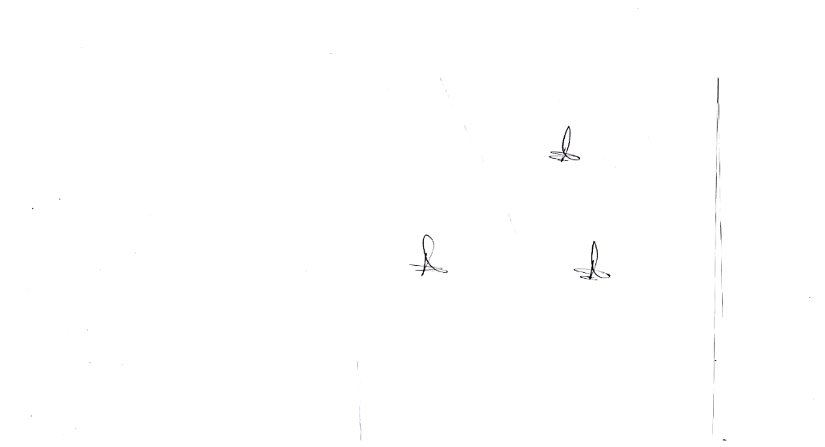
Routine of First Achievement Test 2081
Principal


Green Society Public School
Ratnanagar-7, Sauraha, Chitwan

Routine of First Achievement Test 2081
Date/  Class | 4 | 5 | 6 | 7 | 8 | 9 | 10
2081-02-25 | सामाजिक+  Eng-II | नेपाली+  Eng + Eng II | Eng + सामाजिक+  HRHG | सामाजिक +  Eng | Science +  Opt + HRHG | नेपाली+  Eng | English + Nepali
2081-02-27 | Eng + Maths+  Comp | Maths + Comp | Maths +  Eng II | Science + Eng II | Maths +  HPCA | Comp + Science | Science + सामाजिक
2081-02-28 | Science  +  HRHG | सामाजिक+  HRHG | नेपाली + HPE | HPCA +  Nepali + Comp | नेपाली+  English | Maths +  सामाजिक | Comp + Maths
2081-02-29 | नेपाली+HPE | Science + HPE | Science + Comp | HRHG + Maths | सामाजिक + Comp | Env. Sci + O.Maths | O. Maths  + Eco
Principal


Green Society Public School
Ratnanagar-7, Sauraha, Chitwan
Date/  Class | 4 | 5 | 6 | 7 | 8 | 9 | 10
2081-02-25 | सामाजिक+  Eng-II | नेपाली+  Eng + Eng II | Eng + सामाजिक+  HRHG | सामाजिक +  Eng | Science +  Opt + HRHG | नेपाली+  Eng | English + Nepali
2081-02-27 | Eng + Maths+  Comp | Maths + Comp | Maths +  Eng II | Science + Eng II | Maths +  HPCA | Comp + Science | Science + सामाजिक
2081-02-28 | Science  +  HRHG | सामाजिक+  HRHG | नेपाली + HPE | HPCA +  Nepali + Comp | नेपाली+  English | Maths +  सामाजिक | Comp + Maths
2081-02-29 | नेपाली+HPE | Science + HPE | Science + Comp | HRHG + Maths | सामाजिक + Comp | Env. Sci + O.Maths | O. Maths  + Eco

Routine of First Achievement Test 2081
Principal

